

**Purpose :**

This technical challenge is for candidates to demonstrate their problem solving and learning abilities. All task based on whatever you are going to work with Dezzex Technology Pvt. Ltd. As per your job description. This task you have to solve within 2 days after receiving the document. We hope you not only solve the challenge but learn something new out of it.

This problem is designed for **Jr. Frontend Developer** to understand their problem solving skill, so that they can learn and perform better in their career.

**Rules First :**

1. Try to use updated version of React js.

2. You should keep your code **simple and focused on readable**. Include instructions for running and reading your code in README file. We value thoughtfully written clean and communicative code so other contributors can easily understand and build on top of it. Use proper variables name, function name and classes name as per object-oriented way. All functions should have a docstring (commented details of functionality)

3. Don’t send us file, but upload your application on git hub as private and send us the link.

4. Deploy your application on Amazon Web Service, Azure or Google Cloud. Don’t think you do not have knowledge of it. It is free for sometime. Learn something new. If you will successfully deploy your application on any of this cloud server, we can understand your self-learning abilities. And send us the public IP so we can run it.

5. Don’t forget to stop server, either after free service they will charge for it.

6. You can complete this problem before the given date.

7. **Design should be responsive, we will test it on all platform.**

**8. Create the dashboard with functionality. Use online rest API for populate information.**

**Use Technology :**

1. React js

2. Bootstrap

**The Problem :**

<https://xd.adobe.com/view/cc10c2ed-140f-4c9a-a864-47035bc9f015-9943/>

Create the dashboard design using React js .You have to create a login page (any design) and after sign in, user can see this dashboard.

After completing the task share the gtihub link or deploy on aws / azure or any other cloud platform .

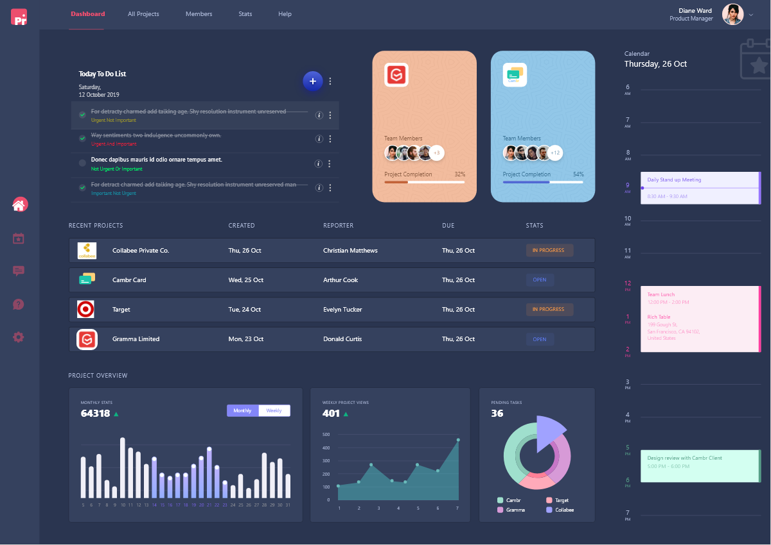

**Convert this given adobe XD design into HTML form using React js and Bootstrap technology.**

1. Don’t use image data for everything, it is not a good practice, but convert this design into CSS.

2. **Your design must be responsive, we will test it on all platform.**

**All the best !**

**Dezzex Technology Pvt. Ltd.**